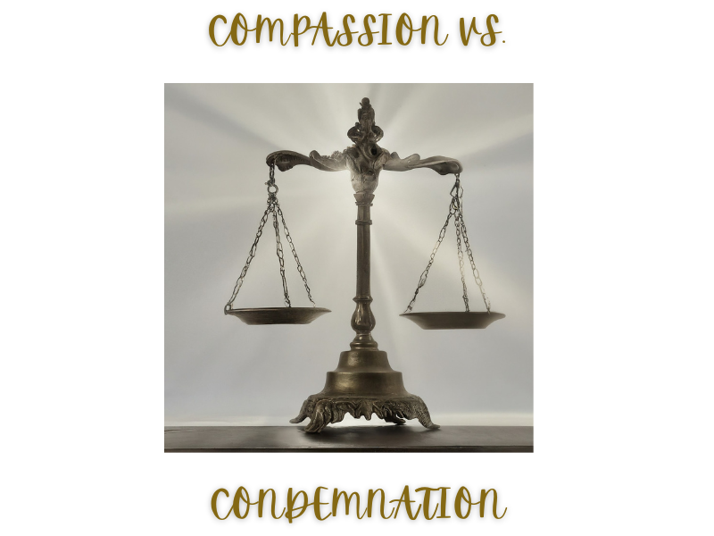
Figure 1 - image generated by Canva AI, 2024

© Creative Commons Copyright, John Edmiston, 2024
May be freely used for Christian ministry purposes but may not be sold in any way.
This extended Bible study by Rev. John Edmiston explores the question of “to judge or not to judge” based on Scriptures in the New Testament.
It is designed to be discussed in a small group setting over a few weeks.
Compassion vs. Condemnation
God had compassion and mercy upon the great city of Nineveh, even though it was wicked. Jesus ate and drank with sinners. However, Paul tells us to reject heretics and not to eat with immoral people. Daniel served in the courts of Babylon as head of the astrologers. Esther lived in a harem for a while. Yet Abraham stood apart from Sodom and refused its wealth.
One of the key teachings of evangelical Christianity is the doctrine of separation:
2 Corinthians 6:14-18 Do not be unequally yoked with unbelievers. For what partnership has righteousness with lawlessness? Or what fellowship has light with darkness? (15) What accord has Christ with Belial? Or what portion does a believer share with an unbeliever? (16) What agreement has the temple of God with idols? For we are the temple of the living God; as God said, “I will make my dwelling among them and walk among them, and I will be their God, and they shall be my people. (17) Therefore go out from their midst, and be separate from them, says the Lord, and touch no unclean thing; then I will welcome you, (18) and I will be a father to you, and you shall be sons and daughters to me, says the Lord Almighty.”

This creates the problem of how to be separate while still functioning in the world. For example, the vegetarian diet of the Hebrew captive youth in Babylon, in order to avoid food dedicated to idols. How can we be in the world and yet not of the world and where are the proper boundaries and attitudes that Christians should adopt in judging or discerning others? Where are the boundaries of the community of those who call themselves Christians? What is clearly, definitely and absolutely “unChristian”?
James tells us to be slow to speak and that the anger of man does not produce the righteousness of God (which rules out hasty, angry Internet trolls): James 1:19-20 Know this, my beloved brothers: let every person be quick to hear, slow to speak, slow to anger; (20) for the anger of man does not produce the righteousness of God.

Our anger can be genuine, real and biblically based; in which case we are called to be angry and yet not sin (Ephesians 4:26). However, it can also come from expectations grounded in our class, culture, education and tradition, as well as from our basic human temperament.

There are two Greek words for judgement:
- Krino – to judge the whole human being as good or evil, this is forbidden.
- Dokimazo – to discern, test, approve – item by item, point by point, this is expected of Christians. It gets into the particulars. This exact doctrine is right or wrong etc.
We do not “sit upon the throne” of judgement, only God does that! If we think we can do that we are wrong. We can, however, make distinctions between right and wrong doctrine and righteous and unrighteous behavior.

Q1. Read Luke 5:27-32, 7:31-50, 19:1-10
How could Jesus be a “friend of sinners” without sinning?
What was Jesus’ agenda / reason for befriending sinners?
Did Jesus participate in their sins?
What was wrong with the attitude of the Pharisees and their idea of separation by rejection and condemnation?
How can we be separate but gracious at the same time?

Q2. Read Romans 14: 1-23
What sort of issues are debatable issues of personal conscience?
Who are the “weak” and who are the “strong”?
How are the weak and the strong to relate to one another?

Q3. Read the following passages about “the traditions of men” and how they create false issues of conscience. How does human tradition lead us into judgmentalism: John 7:19-24, 8: 59, 10:31, 39; Mark 7:5-13, John 3:5,8-10; ,Leviticus 12:3, Luke 6:6-11, Luke 13:10-17

Q4. Read Luke 12:13,14
Why did Jesus refuse to get involved with the dispute over the inheritance?
When is it our time to speak up, and when are we just meddling in matters that are not our own?

Q5. Read 1 Corinthians 5: 9-13
What type of people are outside of our scope of judgment and discipline, and why?
How can Christians be “non-judgmental” at work and in society, and yet holy in Christian community?

Q6. Read Galatians 2:11-14 and Acts 15:36-41
Which dispute was necessary and justified and which dispute was just a sharp personal judgement?

Q7. Read Matthew 7:1-6 and Luke 6:31-38
How does God expect us to be gracious towards others, and why?

Q8. Read Acts 17:16,22,23
What was Paul’s internal reaction when he saw all the idols in Athens? How did Paul turn this into a gospel talking point? How are we to wisely control our strong internal reactions to a grossly sinful society? How will the Holy Spirit help us to be meek, gentle and kind while doing evangelism?

Q9. Read 1 Corinthians 4:1-5, James 4:11,12
Why is the “krino” style of absolute judgement built on faulty theological premises?

Q10. Read 2 Corinthians 10:12-18
What are some of the problems that will occur if we compare ourselves to other folk, or if we compare our ministry to the ministry of others?

Q11. Read 1 Timothy 1:8-11, 1 Corinthians 5:11-13
1 Timothy 1:11 says that a wicked lifestyle “contrary to sound doctrine”. Yet we tend to think of doctrine as being solely theological. How does the gospel include strong ethical and behavioral components? Can you name some of them? Therefore, why is it impossible for Christians to affirm a morally wicked lifestyle? How are we to react to moral deviancy within the Church?
Q12 Read 2 Timothy 3:1-5, 2 John 1:7-11, Titus 3:9-11
What is to be our attitude toward those who deliberately distort the basic teachings concerning Jesus Christ? Why cannot we even greet them, let alone bless them?

Q. 13 How do Jesus and the Apostles respond to the following eight types of sinners:
A. Seeking Sinners: John 4:7-15
B. Penitent Sinners: Luke 23:39-43
C. Ignorant Sinners: Luke 23:33,34
D. Inadvertent Sinners: 1 John 1:7-10, 5:16,17
E. Persistent Sinners: 2 Peter 2:20-22
F. Hardened Sinners: John 12:36-43, Daniel 5:20, Matthew 23:13-15
G. Seared Sinners: 1 Timothy 4:1-5, Titus 1:15,16
H. Sons of Perdition / Those Who Take the Mark John 17:12, 2 Thessalonians 2:3, Revelation 14:9-11

Q. 14 Proverbs tells us that it is wise to avoid or at least greatly distrust certain foolish and wicked types of people such as gang members, false messengers, immoral people, sluggards, boorish fools, those wise in their own eyes, gossips, those given to change and so on (Proverbs 1:10, 4:14,15; 9:13-18). In the light of this, how is the Christian to draw careful and wise boundaries in their business, professional and personal life? Why is this kind of “judging” totally Biblical, necessary and legitimate?

Q. 15 Read 1 Timothy 5:3-16
We tend to judge the needy, broken, vulnerable and unsuccessful. Or, we try to rescue them and end up with toxic giving which creates dependency and/or encourages sinful lifestyles (e.g. the younger widows). Who should be the first line of care for the most vulnerable among us (widows in the passage above are just one example of vulnerable people)? Should we encourage the restoration of the idea of the extended family where people provide care for each other? How can we help the helpless? When should the Church step in? On one hand we are not to be selfish and harsh, for God loves a cheerful giver. On the other hand, we cannot meet every single need that comes our way. How can the principles of 1 Timothy 5 guide us in who to help, and how to help?

Contact the author, John Edmiston at: johned@cybermissions.org

